 | 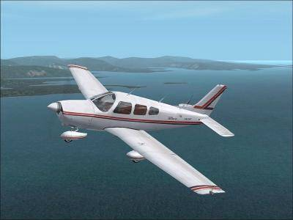 | Airstrip Committee Agenda  June 24, 2006  10:30 a.m.  POA Activities Building
Agenda
- Call to order and approval of the Agenda
- Approval of the May 27, 2006 meeting minutes
- Application Review Committee Report – Wayne Underwood and Dick Sager
- Unfinished Business
- Update on the possibility of becoming a public airstrip – Dick Sager
- Update on www.AirNav.com – Paul Daugherty
- Craft Show July 1 – review booth content and work schedule
- Update on the yearly brush hog of the airstrip – Paul Daugherty
- Update on obtaining a roller for the airstrip
- Hanger Homes – review information from Jim O’Dea and Buster Robbins and prepare recommendation for POA board
- T-Hanger review costs to build and potential income provided by Don Cornwell and prepare recommendation for the POA board
- New Business
- List of volunteers to drive pilots to the club house – Dick Sager
- Begin initial discussion on creating a master plan for the airstrip to include airstrip access points, drainage requirements and taxiways
- Adjournment

