 | 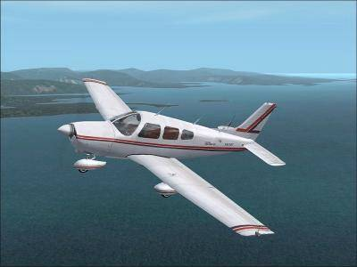 | Airstrip Committee Agenda  May 27, 2006  10:30 a.m.  POA Activities Building
Agenda
- Call to order and approval of the Agenda
- Approval of the April 29, 2006 meeting minutes
- Application Review Committee Report – Wayne Underwood and Dick Sager
- Unfinished Business
- Update on the possibility of becoming a public airstrip – Dick Sager
- Update on leveling and marking commons parking area including the commons between lots 374 and 375 – Dick Sager and Paul Daugherty
- Update on www.AirNav.com – Roger Allen and Paul Daugherty
- Craft Show July 1 – booth content and work schedule
- Update on the Bulletin Board on the airstrip – Dick Sager
- Update on the yearly brush hog of the airstrip – Paul Daugherty
- Update on borrowing roller from Gladwin airport – Don Cornwall
- Hanger Homes Information – Dick Sager and Wayne Underwood
- T-Hanger costs to build and potential income – Don Cornwell
- New Business
- Update on the possibility of Buildings and Grounds assisting with installing culverts on commons for accessing the airstrip – Paul Daugherty
- Determine guidelines for glider usage on the airstrip
- Begin initial discussion on creating a master plan for the airstrip to include airstrip access points, drainage requirements and taxiways
- Election of Chairperson and Secretary for 2006-7
- Adjournment

