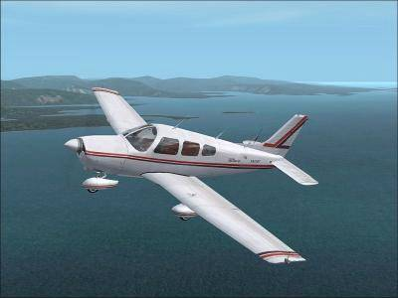 | Airstrip Committee Agenda  June 23, 2007  10:30 a.m.  POA Activities Building

- Call to order and approval of the Agenda
- Approval of the May 26, 2007 meeting minutes
- General Manager’s report
- Application Review Committee Report – Wayne Underwood and Dick Sager
- Unfinished Business
- Update on safety cones that will be provided, free of charge from the State – Dick
- Update on how much parking space the Michigan Aeronautic Commission (MAC) requires. Will we need the commons between lots 374 and 375? - Dick
- Update on the yearly brush hog of the airstrip. As a public use airstrip we need to have 50 feet from each side of the center of the airstrip cleared – Paul Daugherty
- Update on a roller for the airstrip. At the May 26, 2007 the committee asked Dick Sager to see if we can get parts or a roller from the State of Michigan
- Update from Roland MacDonald on asking the local Realtors if they are interested in advertising on AirNav.com
- Contact the MAC to get assistance from airport planners at no charge to create a master plan for the airstrip to include airstrip access points, drainage requirements and taxiways.
- Status on required signage for public use airstrip: Parking for cars and planes
- Update from Dick Sager regarding the airstrip be listed as no snow removal rather than closed during the winter.

- New Business
- Craft Show July 7
- Adjournment
2007 Meeting schedule:
- September 1, 10:30 a.m. lower level of Hearth restaurant

