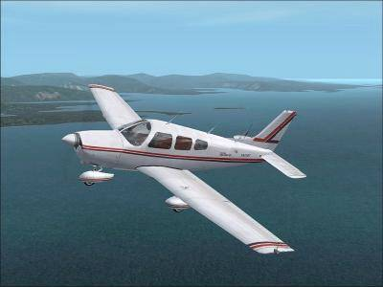 | Airstrip Committee Agenda  May 26, 2007  10:30 a.m.  POA Activities Building

- Call to order and approval of the Agenda
- Approval of the September 2, 2006 meeting minutes
- General Manager’s report
- Application Review Committee Report – Wayne Underwood and Dick Sager
- Unfinished Business
- Update on safety cones that will be provided, free of charge from the State – Dick
- Update on how much parking space the Michigan Aeronautic Commission (MAC) requires. Will we need the commons between lots 374 and 375? - Dick
- Update on the yearly brush hog of the airstrip. As a public use airstrip we need to have 50 feet from each side of the center of the airstrip cleared – Paul Daugherty
- Update on a roller for the airstrip. At the September 2 2006 meeting Dick, Don Cornwall and Wayne Underwood agreed to start looking for parts to build a large roller.
- Update from Roland MacDonald on paying the $12 fee and writing the ad for AirNav.com. At the June 2006 meeting, Roland MacDonald volunteered to pay the fee and write the ad for the site. Roland will also ask the local Realtors if they are interested in advertising on the site
- Contact the MAC to get assistance from airport planners at no charge to create a master plan for the airstrip to include airstrip access points, drainage requirements and taxiways.
- Results from article in the Sugar Scoop about members interested in renting a hanger on the airstrip.
- New Business
- Status Michigan Aeronautic Commission (MAC) provided and required signage for public use airstrip: Parking for cars and planes
- Ideas to promote the Airstrip
- How is our airstrip listed for winter? Is listed as closed or no snow removal?
- Craft Show July 7
- Ideas for promoting the airstrip
- Elect Officers
- Adjournment
2007 Meeting schedule:
- June 23, 10:30 a.m. Activities building
- September 1, 10:30 a.m. lower level of Hearth restaurant

